SRI A S N M GOVERNMENT COLLEGE(A),PALAKOL-534260

DEPARTMENT OF COMPUTERS LAUNCHED A CERTIFICATE COURSE

ON MS-OFFICE TOOLS Dated:03-03-2022

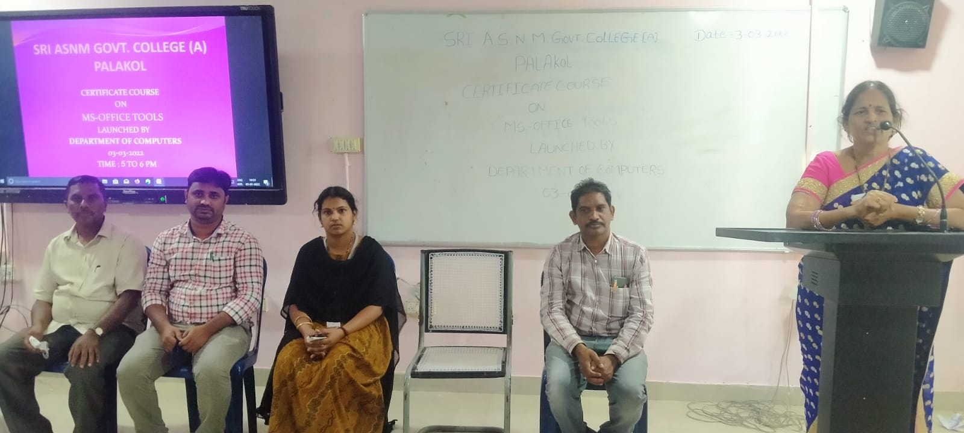

In this context Our beloved Principal Dr.T.RajaRajeswari Garu presided this function and she spoke about the importance of computer skills. so, all of you must learn the computer skills with in the stipulated time and it is useful in future. And the HOD of Computer science Sri K.Bhadrachalam has given the message regarding the concept. Sri Ch. Ravikumar and other faculty members and students are participated in this occation.

